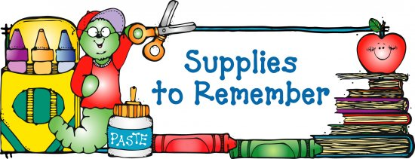

**7th Grade Supply Lists (All Subjects) for 2017 - 2018**

**____☺ $10.00 (Cash only) to purchase supplies such as tissues, paper towels,**

**disinfecting wipes, hand sanitizer, etc. throughout the year**

**____☺ 1- green spiral 3-subject notebooks (perforated pages) *(science)***

**____☺ 2- purple spiral 1 subject notebook (perforated pages) *(social studies)***

**____☺ 1- black spiral 1 subject notebook (perforated pages) *(Spanish)***

**____☺ 1- 13 pocket letter size mesh/fabric or plastic accordion folder with closure**

**____☺ 1- 1- blue, spiral, 3-subject notebook that includes folders *(for language***

***arts)***

**____☺ 1- large, yellow, sewn composition book for notes and homework *(religion)***

**____☺ 2- large, red, sewn composition books for notes and homework *(math,***

***Mrs. Monthony, Mrs. McCarron, Ms. Bloom)***

**____☺ 1- 2 pocket folder for notes and homework (*music*)**

**____☺ 1- scientific calculator eg. TI-30 or similar model**

**____☺ 1- 6 inch standard/metric ruler**

**____☺ 1- 150 sheet pack of WIDE ruled loose-leaf paper *(homeroom)***

**____☺ 1- pack of grid index cards (4 x 6) for graphing (*math*)**

**____☺ 1- pack of lined MIXED COLOR index cards (3 x 5) *(social studies)***

**____☺ 1- pack of lined white index cards (3 x 5) *(science)***

**____☺ 1- pack of small *Post Its* (multiple color, 1.5” x 2” or colored flags)**

***(language arts)***

**____☺ 2 - pack of 10 or 12 blue or black pens (*homeroom*)**

**____☺ 1- dozen pencils *(homeroom)***

**____☺ 6- brown paper grocery bags for book covers**

**____☺ Earbuds for using with computers**

**____☺ Chrome book case--Solid Black Evecase 11.6 Neoprene Padded Slim**

**Sleeve with colored trim (available from Amazon)**

**A soft pencil case with the following items:**

MC900234087[1]

**☺ 4 highlighters- multiple colors including yellow**

**☺ No. 2 pencils**

**☺ Black or blue ballpoint pens**

**☺ Red pen/pencil**

**☺ Eraser**

**☺ small *Post It* tabs for tabbing purposes**

**☺ manual pencil sharpener**

**Please purchase enough supplies to last the school year. Recheck your child’s supplies throughout the year and replenish as necessary.**