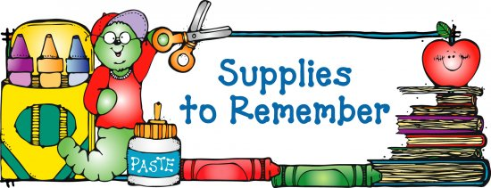

**6th Grade Supply List** ***(all subjects)***

**____☺ $10.00 (Cash only) to purchase supplies such as tissues, paper towels,**

**disinfecting wipes, hand sanitizer, etc. throughout the year**

**____☺ 1- green spiral 3 subject notebook (perforated pages) (*science*)**

**____☺ 1- black spiral 1 subject notebook (perforated pages) *(Spanish)***

**____☺ 2- purple spiral 1 subject notebook (perforated pages) *(social studies)***

**____☺ 1- 13 pocket letter size mesh/fabric or plastic accordion folder with closure**

**____☺ 2- large, red, sewn composition books for notes and homework *(math,***

***Mrs. Monthony, Mrs. Bloom and Mrs. McCarron)***

**____☺ 1- large, yellow, sewn composition book for notes and homework *(religion)***

____**☺ 1- 2 pocket folder for notes and homework (*music*)**

**____☺ 1- blue, spiral, 3-subject notebook that includes folders *(for language arts)***

**____☺ 1- scientific calculator eg. TI-30 or similar model**

**____☺ 1- 6 inch standard/metric ruler**

***____*☺ 1- pack of graph paper (not a pad) (*math*)**

**____☺ 1- pack of lined index cards (3 x 5) *(social studies)***

**____☺ 1- pack of SMALL *Post Its* (multiple color, 1.5” x 2” or colored flags) *(language arts)***

**____☺ 2- pack of 10 or 12 blue or black pens (*homeroom*)**

**____☺ 1- dozen pencils *(homeroom)***

**____☺ 6- brown paper grocery bags for book covers**

**____☺ ear buds for using with computers**

**____☺ Chrome book case--Solid Black Evecase 11.6 Neoprene Padded Slim**

**Sleeve with colored trim (available from Amazon)**

MC900290934[1]**A soft pencil case with the following items:**

**____☺ 4 highlighters- multiple colors including yellow**

**____☺ No. 2 pencils**

**____☺ Black or blue ballpoint pens**

**____☺ Red pen (for editing and correcting)**

**____☺ Red pencil**

**____☺ Eraser**

**____☺ Manual pencil sharpener**

**Please purchase enough supplies to last the school year. Recheck your child’s supplies throughout the year and replenish as necessary.**